**ILR-10K IN-LINE RESISTOR**

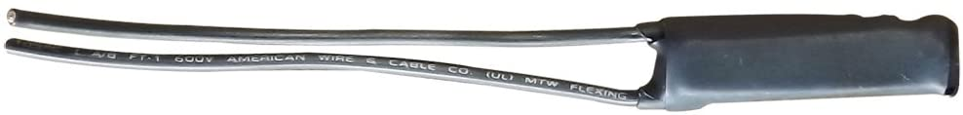

|  |  |
| --- | --- |
| **MODEL** |  |
| ILR-10K | In-Line Resistor |
| **ELECTRICAL** |  |
| Power Requirements | 120VAC 50Hz/60Hz |
| Connections/Power Wire | Two 16 AWG gauge   105 C insulation  Black –  Line and Neutral (see wiring diagram) |
| Environmental Conditions | Indoor Use Only or water-proof enclosure  Temperature: -40° to 194°F (-40° to 90°C)  Humidity: 10% to 90% RH (non-condensing) |
| Certifications | Safety tested for USA and Canada to ETL tested to UL508  UL-508-2010  CSA C22.2 #14-2010 |
| **OPERATION** |  |
| Filtering | Cuts off certain LED fixtures/bulbs residual load (very dim) when turning switch off (0% Level). |
| Status LED Modes | None |
| LED Indicators | None |
| During Power outage | None |
| Set-Up Mode | None required. |
| **MECHANICAL** |  |
| Button Type | None |
| Mounting | Wired |
| Dimensions | Height: 2.0 in Width: 0.50 in  Depth: 0.50 in |
| Weight | 1 oz. |
| Warranty | 5 years |
| US Patent No. | 6,734,784; 6,784,790; 7,265,654; 7,688,183. U.S. and foreign patents may be pending. |