**MAGNEPULL  
PART # 42800**

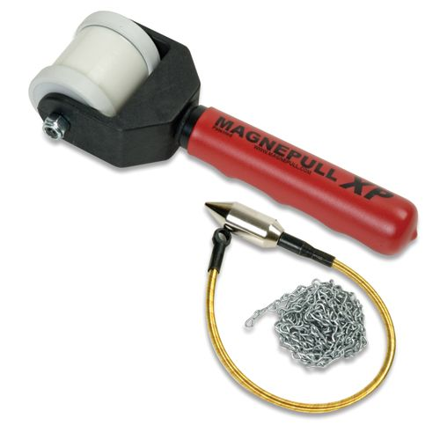

Extremely powerful, yet delicate, magnetic wire snake for fishing wire through walls. It even works through insulation! The Magnepull kit includes a strong rare earth magnetic roller with a smooth surface and rare earth magnetic bullet leader.  
  
**Features**

* Hand roller with powerful magnet and smooth finish to avoid damaging walls
* 6′ jack chain included
* Flexible leader with magnet head
* Also makes a great stud finder